DEPARTMENT OF COMPUTER ENGINEERING Experiment No: 1

|  |  |  |  |  |
| --- | --- | --- | --- | --- |
| Semester | | S.E. Semester IV – Computer Engineering | | |
| Subject | | Database Management Systems Laboratory. | | |
| Lectures Professor In-charge | | Prof. Suja Jayachandran | | |
| Practicals Professor In-Charge | | Prof. Suja Jayachandran | | |
| Laboratory number | | M312 | | |
| Student Name | Sahil Patil | |  | |
| Roll Number | 22102A0065 | |  | |
| Grade |  | | Teacher’s Signature | |
| Experiment No: | 3 | | |
| Experiment Title | Mapping ER Diagram to Relational Tables.. | | |
| Resources /  Apparatus  Required | Hardware:  Software:  PC  Draw.io | | |
| Objectives  (Skill Set /  Knowledge  Tested /  Imparted) | 3) Modify ER diagram and create their relational tables. | | |
| Historical Profile | Peter Chen developed ERDs in the 1970s and published his proposal for entity relationship modeling in a 1976 paper titled "The  Entity-Relationship Model: Toward a Unified View of Data". Peter Chen was a computer scientist who worked on improving database design. | | |
|  |  | | |
|  |  | | |
| Theory | Design a database for the bank . Activities that can be proposed involve following data : -  Entity- ( Attributes)   1. **PATIENT-**(name, address, patient-id, diagnosis) 2. **REGISTRATION-**( mob-no, date, email-id, payment, policy, 3. **MEDICAL RECORD-**( patient problem, drugs, diagnosis, date of examination, record-id ) 4. **INVENTORY-**( furniture, water management, electricity ) 5. **HOSPITAL-**( years, city, address, name, id ) 6. **DOCTOR-**( qualification, date of joining, salary, Dr-id, Dob,expertise, name ) 7. **STAFF-**(staff-id, salary ) | | |

|  |  |
| --- | --- |
| ER Diagram,  Tables |  |

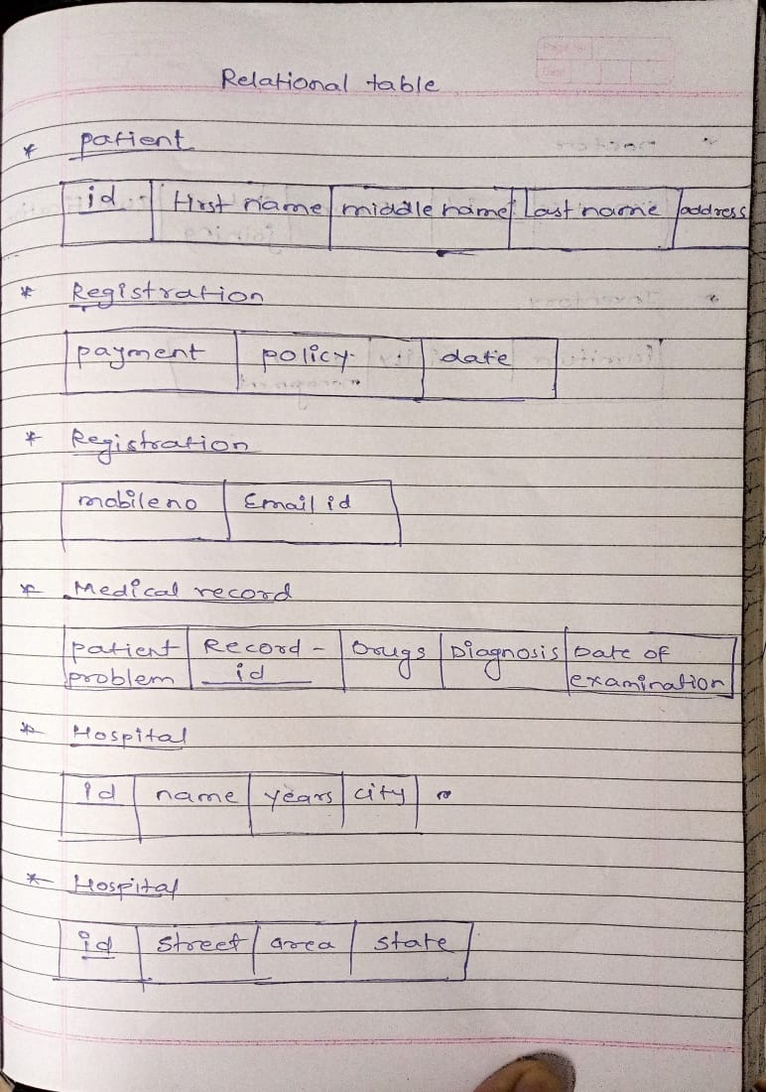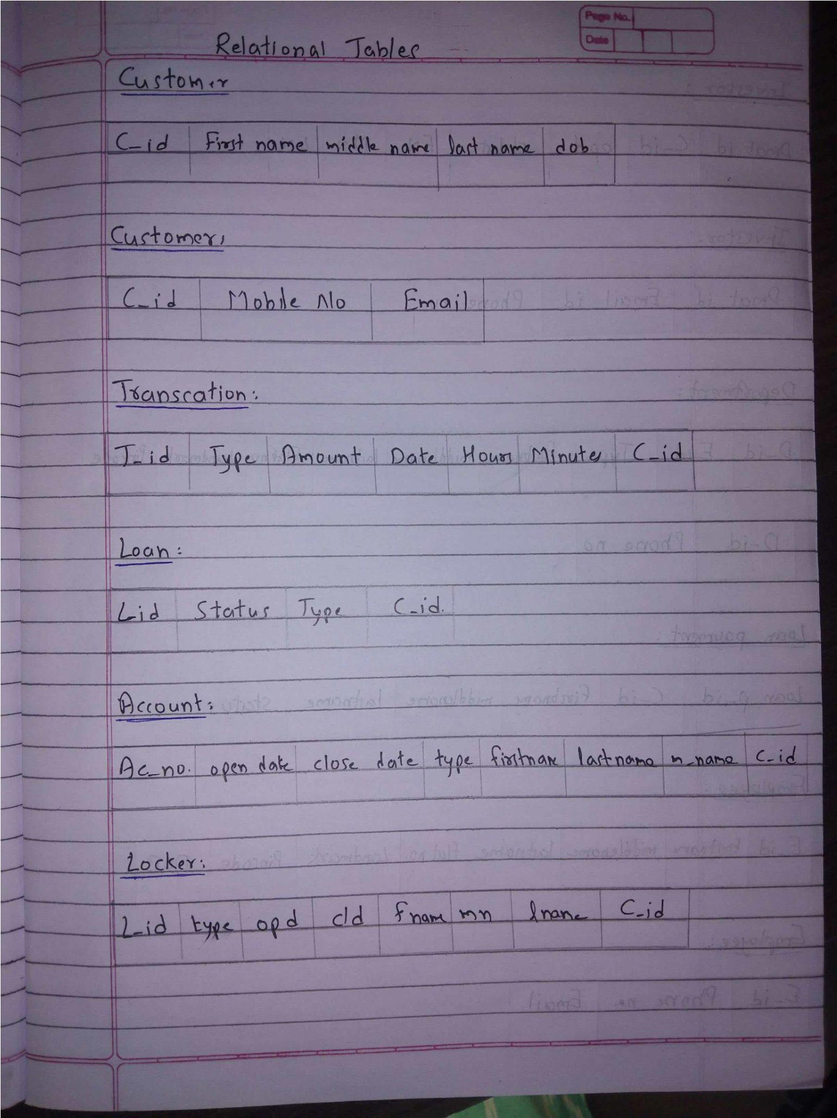

|  |  |
| --- | --- |
|  |  |
| Conclusion | The ER diagram has been modified according to new requirements and the relational tables have been created successfully. |
| Real Life Application | * HOSPITAL MANAGEMENT * HEALTH AREA * GOVERNMENT DATABASE |